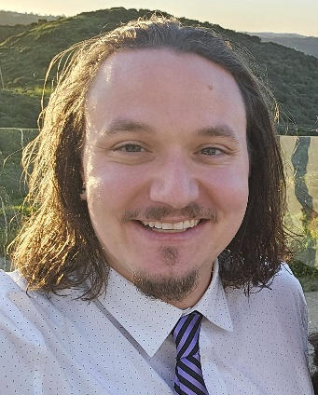
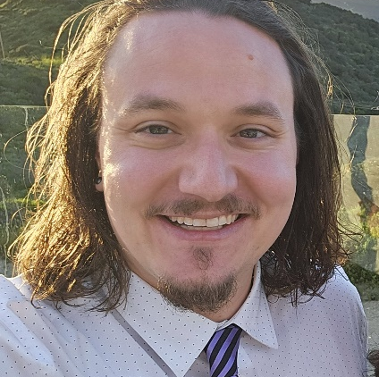
a
COLBY BECKETT
S e n i o r F X A r t i s t

C O N T A C T
colbybeckett@gmail.com
Long Beach, California
linkedin.com/colbybeckett
colbybeckett.com
https://vimeo.com/showcase/11593950
E D U C A T I O N
Bachelor of Fine Arts -
Media Arts and Animation
Illinois Institute of Art
Schaumburg

T E C H N I C A L
S K I L L S
- Houdini
- Mantra
- USD
- Solaris/Karma
- Redshift
- VEX/Python
- Nuke
- 3D Studio Max
- Thinking Particles
- FumeFX
- Vray
- PhoenixFD
- Adobe After Effects
- Adobe Photoshop
- ZBrush
- Cinema4D
- XParticles
- 3D Printing
- Shotgrid
- Deadline Monitor

P R O F I L E
Results-driven professional with a proven track record of success in film, television, and commercials. Focusing my skills on a career where I can utilize my exceptional leadership, technical skills, and problem-solving abilities. I thrive in dynamic, demanding environments with an emphasis on project efficiency and growth. I am eager to leverage my talents to contribute to any challenge that presents itself.
P R O F E S S I O N A L E X P E R I E N C E
Senior FX ARTIST
EdgLrd | Remote | Dec 2025 – Feb 2026
- Utilized Houdini and Redshift to deliver a multi-shot 4k cinematic for Marathon marketing.
- Completed final simulations for compositing which included lighting, texturing, animating and rendering.
FX ARTIST
Paramount Animation Studios| Remote | Sept 2025 – Dec 2025
- Utilized Houdini’s Rigid Body’s, Cloth, Pyro, and Crowd systems to craft 2D/3D FX with properly rendered AOV’s within Karma/Solaris.
- Built Houdini Pipeline tools for file incrementation and pathing within a Linux based pipeline
SENIOR FX ARTIST
NotShibuya | Remote | Sept 2022 – Nov 2024
- Collaborated with a team of artist to create an Emmy Award winning Short Film, White Rabbit
- Designed FX assets for a MTV nominated Linkin Park Music Video.
- Utilized Houdini’s Pyro, Rigid Body’s and Ocean Tank systems to establish FX look development and translation to a 2d style

SENIOR FX ARTIST
EncoreVFX | Burbank, California / Remote | Sept 2017 – Feb 2023
Crafted a wide range of realistic simulations alongside my CG supervisor and FX leads for multiple CW superhero shows including The Flash, Supergirl, Black Lightning, Batwoman and Doom Patrol.

- Utilized Houdini to deliver over 700 completed shots that had Volumetrics, sparks, lightning, magic, debris, fire, and destruction.
- Effectively communicated with a production team to ensure on time deliverables within appropriate budget constraints.
- Leveraged my problem-solving abilities to think of new and cost-effective ways to the reach the client’s vision.
- Adaptable team player with willingness to learn new techniques depending on the situation.
- Helped guide junior artists on industry standard practices.
- Maintained a positive and professional attitude in challenging situations
a
FX ARTIST
Cinergy Creative | Remote | Mar 2017 – April 2017
- Art directed building destruction in accordance with client specification for television.
3D GENERALIST
WickedLiquidFX | Irvine, California | June 2010 – Sept 2017
Post-production house specializing in quality motion graphics, 3d animation and visual effects.
- Implemented my personal skill set, knowledge and creative abilities into complete final animations.
- Coordinated with clients and project managers to create designs and tasks in a timely and cost-effective manner.
- Proficient in Camera Animation, Modeling, Lighting and Texturing/Shading of final assets.
- Managed renders and checked for quality assurance to enable project delivery on time, per client’s requests.
- Utilized current computer software to apply technical skills for new and fresh ideas to projects.

CLIENTS WITHIN WICKEDLIQUIDFX
Edwards LifeSciences
Brand Management Department- Creative Management
- Visualized heart valve replacement procedures for a marketing tool for doctors and their patients.
- Converted accurate to scale models from engineered CAD files for a true scientifically precise animation.
Dawn - Titans / Not Above That Music Videos
Creative Director - Monty Marsh
- Utilized the Microsoft Kinect to Facial Track and Motion Capture a contemporary dance routine.
- Implement the captured data into a fully developed art piece.
MAST Therapeutics – Vepoloxamer
Client – Electric Eye. Creative Director – Dave Klemens
- Visualized chemical compound that assists patients that suffer with sickle cell anemia for marketing towards doctors.
- Created, animated and rigged chemical compound based on client’s interpretation.
Beachbody – TurboFire
Client – ScriptToScreen. Producer – Darryl Garcia
- Implemented clients design’s to portray an overall brand message to consumer.
BREG - FreeRunner
Client – Electric Eye. Creative Director – Dave Klemens
Boston Scientific – Infineon 16
Client – StudioPMG. Producer – Nate Rupple
Virgin Mobile – Virgin Optimus
Client- ChopShop. Creative Director – Zach Lions
Wetzel’s Pretzels – Words Of Wetzel
Client/Producer – Chopshop

